**2022 Telescope/Binocular Observer’s Challenge:**

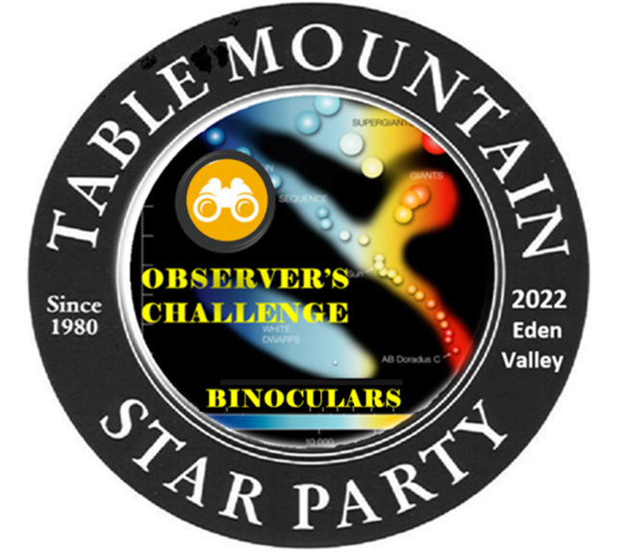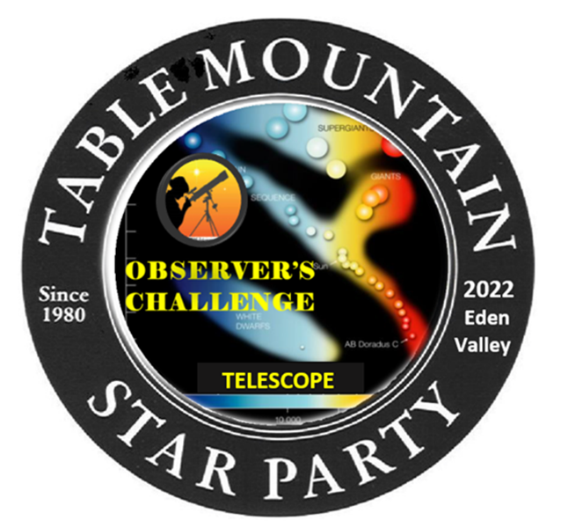 If you came to the Table Mountain Star Party (TMSP) with your binoculars or have access to binoculars while at the TMSP this program is for you. This program will give you an opportunity to observe 50 or more showcase objects under the ideal conditions of the pristine Eden Valley skies. It’s not super challenging this year but will get progressively harder each year. You will get a button for finding just oneof the objects from each category on the list. All observations must be done during the TMSP.

You must find the objects yourself, without help from anyone else. For at least three of the objects, you must sketch what you see through your binoculars or telescope. This year the Binocular and Telescope Observer’s Challenge is concentrated on stellar evolution. “From Dust to Dust”.

Everything that you see in the night sky is visible to you because of light from a star. The stars themselves, nebulae, planets, moons, are visible because of starlight. Even dark nebulae are visible because they block the illumination of stars or other objects lit up by stars. We exist because early generations of stars generated the elements that make up our planet and the chemical elements required for life. It is not an understatement to say that we exist because stars exist.

The purpose of this Observer’s Challenge “Stellar Evolution” is to develop in the observer an appreciation for the most common objects that they see in the night sky – the stars. Stars, like us, are born, live their lives and end their lives. Understanding this 'stellar evolution' is important to understanding how the universe works.

Our hope is that in addition to performing the observations, you will have enough information to put each object into the context of stellar evolution. In the end, observing is something you do in your mind. It's not about simply seeing the object, it's about understanding what the object is, why it is important, why it is interesting and how it fits into the story. Once you do, you'll be able to say 'Oh, WOW' for objects that you may have overlooked or may have underappreciated in the past.

Any size binoculars or telescope can be used. All objects are within range of small to medium sized binoculars and are available for observation between 10:00PM and 4:00AM any time during the TMSP.

******To receive your button, turn in your observations to ***Mark Simonson or Ron Mosher (Observation Challenge Coordinators)*** any time during the TMSP. If you finish the list the last night of TMSP, and we are not available to give you your button, just mail your observations to me at 1519 Ridge Dr., Camano Island, WA. 98282, or email your observations to me at [marknilse@yahoo.com](mailto:marknilse@yahoo.com), and I will see that you get a button.

In the early 1900's there was quite a bit of data about stars. We had spectroscopic data for stars, and we had distances to some relatively nearby stars (developed by observing the parallax of the stars). The challenge was to organize this data in a way that helped us understand stars.

In about 1900 Ejnar Hertzsprung and Henry Norris Russell decided independently that plotting the intrinsic brightness of stars (the luminosity) on the Y axis and the temperature of the stars on the X axis might provide some interesting insight into how stars are categorized and how they work. When they did this, they found that most stars fell along a line that went from blue and hot (at the upper left) to red and cool (at the lower right). This line is called the 'main sequence'. The 'main sequence' is where a star stays for 90% or so of its lifetime. As a star ages, its location in the diagram changes. This is a function of its characteristics (color and temperature); this does not represent a change in the star's position in space.

***THE LIST***

**Observer’s Name: ______________________________**

**Binoculars/Telescope ________________________**

***Stellar Nurseries***

Type: E = Emission, R = Reflection, D = Dark

|  |  |  |  |  |  |  |  |
| --- | --- | --- | --- | --- | --- | --- | --- |
| **Name** | **Other Name** | **Con** | **RA** | **Dec** | **Mag** | **Type** | **Note** |
| Rosette Nebula | NGC 2237 | Mon | 06h 30m 55s | +05◦ 02' 52" | 8.0 | E | Large and dim. Credit if you see the OC NGC2244 (Caldwell 50) |
| Cone Nebula | NGC2264 | Mon | 06h 40m 58s | +09◦ 53' 44" | 4.1 | ED | Cone is in southern part of object; the Christmas Tree cluster is at the north |
| Barnard 68 |  | Sgr | 17h 22m 38s | -23◦ 49' 34" |  | D | |  | | --- | | Requires dark skies | |
| Trifid Nebula | M20 | Sgr | 18h 02m 28s | -22◦ 59' 11" | 9.0 | ERD |  |
| Lagoon Nebula | M8 | Sgr | 18h 04m 08s | -24◦ 20’ 15” | 6.0 | ED |  |
| Eagle Nebula | M16 | Ser | 18h 18m 54s | -13◦ 51' 04" | 5.6 | E | Pillars of Creation |
| Swan Nebula | M17 | Sgr | 18h 20m 48s | -16◦ 11' 00" | 9.0 | E | Also called the Omega nebula |
| Pelican Nebula | IC5070 | Cyg | 20h 50m 48s | +44◦ 21' 00" | 8.0 | E | Associated with the North American Nebula, req's dark skies, diffuse |
| North America | NGC7000 /  Caldwell 20 | Cyg | 20h 58m 50s | +44◦ 31' 00" | 8.0 | E | Visible unaided eye under dark skies |
| |  | | --- | | IC1396 | |  | Cep | 21h 39m 06s | +57◦ 30' 00" | 3.5 | E | A cluster with associated nebulosity |

***Colorful Stars (O, B, A, F, G, K, M)***

|  |  |  |  |  |  |  |  |  |
| --- | --- | --- | --- | --- | --- | --- | --- | --- |
| **Name** | **Other Name** | **Type** | **Con** | **RA** | **Dec** | **Mag** | **Note** | |
| Mu And | SAO54281 | A | And | 00h 56m 45s | +38◦ 29' 58" | 3.9 |
| HD14633 | SAO37987 | O | And | 02h 22m 54s | +41◦ 28' 48" | 7.5 | Part of a multiple | |
| Polaris | North Star | F | UMi | 02h 31m 49s | +89◦ 15' 51" | 2.0 | Always visible to northerners | |
| Algol | SAO45864 | B | Per | 03h 08m 10s | +40◦ 57’ 20s | 2.1 | Eclipsing binary – drops to 3.4 every 2.867 days | |
| Lalande 21185 | SAO62377 | M | UMa | 11h 03m 20s | +35◦ 57' 21" | 7.5 | One of the brighter red dwarfs | |
| Theta Boo | 23 Boo | F | Boo | 14h 25m 12s | +51◦ 51' 02" | 4.1 |
| HD 139341 | SAO64800 | K | Boo | 15h 36m 03s | +39◦ 48' 08" | 6.5 | A double star, both K | |
| 14 Her | SAO45933 | K | Her | 16h 10m 04s | +43◦ 49’ 04” | 6.6 |
| Zeta Oph | SAO160006 | O | Oph | 16h 37m 10s | -10◦ 34' 02" | 2.6 |
| Rasalgethi | Alpha Her | M | Her | 17h 14m 39s | +14◦ 23' 26" | 2.8 |
| Rasalhague | Alpha Oph | A | Oph | 17h 34m 56s | +12◦ 33' 34" | 2.1 |
| Barnard's Star | HIP87937 | M | Oph | 17h 57m 48s | +04◦ 43' 26" | 9.5 | Red dwarf, quite dim |
| Vega | Alpha Lyr | A | Lyr | 18h 36m 56s | +38◦ 47' 04" | 0.0 |
| Ross 154 | V1216 Sag | M | Sgr | 18h 49m 50s | -23◦ 50' 12" | 10.4 | Flare star – hydrogen burning |
| Albireo A | Beta Cyg | K | Cyg | 19h 30m 43s | +27◦ 57' 35" | 3.1 | Beautiful – the orange star |
| Albireo B | Beta Cyg | B | Cyg | 19h 30m 43s | +27◦ 57' 35" | 3.1 | Beautiful – the blue star |
| Altair | Alpha Aql | A | Aql | 19h 50m 47s | +08◦ 52' 10" | 0.8 | Altair, Vega, and Deneb form the summer triangle; all are 'A' stars |
| Alfirk | Beta Cep | B | Cep | 21h 28m 51s | +70◦ 33' 39" | 3.2 |
| Iota Peg | 24 Peg | F | Peg | 22h 07m 01s | +25◦ 20' 43" | 3.8 |
| Matar | Eta Peg | G | Peg | 22h 43m 00s | +30◦ 13' 17" | 2.9 | Binary yellow G and whiter F |

|  |  |  |  |  |  |  |  |
| --- | --- | --- | --- | --- | --- | --- | --- |
| **Name** | **Other Name** | **Age** | **Con** | **RA** | **Dec** | **Mag** | **Note** |
| Double Cluster | NGC 884, NGC 869 | ~ 4 M years | Per | 02h 20m 50s | +57◦ 07' 58" | 5.3 | Great sight in Binoculars! |
| M6 | NGC6405 | 100 M years | Sco | 17h 40m 17s | -32◦ 16' 17' | 4.5 | Butterfly Cluster |
| NGC6530 | Col 362 | 2.3 M years | Sgr | 18h 05m 11s | -24◦ 20' 54" | 4.6 | Imbedded in M8 (Lagoon Neb) |
| Wild Duck | M11 | 220 M years | Sct | 18h 51m 06s | -06◦ 16' 00" | 5.8 |

***Young Open Clusters***

***Main Sequence Low Mass Stars***

|  |  |  |  |  |  |  |  |
| --- | --- | --- | --- | --- | --- | --- | --- |
| **Name** | **Other Name** | **Color** | **Con** | **RA** | **Dec** | **Mag** | **Note** |
| Gliese 67 | HD 10307 HIP 7918 | G | And | 01h 41m 48s | +42◦ 36' 46" | 5.0 | .97 solar mass |
| Tau Cet | HIP 8102 | G | Cet | 01h 44m 03s | -15◦ 56' 06" | 3.5 | .81 solar mass |
| Eta Ari | SAO 75204 | F | Ari | 02h 12m 48s | +21◦ 12' 40" | 5.2 | 1.3 solar mass |
| Beta Com | SAO 82706 | G | Com | 13h 11m 52s | +27◦ 52' 51" | 4.2 | 1.1 solar mass |
| 18 Sco | SAO 141066 | G | Sco | 16h 15m 37s | -08◦ 22' 15" | 5.5 | 1.0 solar mass |
| Sigma Dra | SAO 18396 | K | Dra | 19h 32m 22s | +69◦ 39' 21" | 4.7 | .82 solar mass |
| 61 Cyg A | HD201091 HIP104214  HR 8085 | K | Cyg | 21h 06m 54s | +38◦ 44' 58" | 5.2 | .63 solar mass.  Brighter member of binary pair |
| 51 Peg | SAO 90896 | G | Peg | 22h 57m 28s | +20◦ 46' 08" | 5.5 | 1.1 solar mass  (Hosts first extra-solar planet ever found) |

***Main Sequence Low Mass Stars (Red Giant Stars)***

|  |  |  |  |  |
| --- | --- | --- | --- | --- |
| **Name** | **Other Name** | **RA** | **Dec** | **Mag** |
| Mirach | Beta Andromedae | 01h 09m 44s | +35◦ 37' 13" | 2.1 |
| Arcturus | Alpha Boo | 14h 15m 39s | +19◦ 10' 36" | -0.1 |
| Scheat | Beta Peg | 23h 03m 47s | +28◦ 05' 00" | 2.4 |

***Main Sequence Low Mass Stars (Carbon Stars)***

|  |  |  |  |  |
| --- | --- | --- | --- | --- |
| **Name** | **Other Name** | **RA** | **Dec** | **Mag** |
| X Cnc | SAO 98230 | 08h 55m 23s | +17◦ 13' 53" | 5.6-7.5 |
| La Superba | Y CVn | 12h 45m 08s | +45◦ 26' 25" | 7.4-10 |
| Herschel's Garnet Star | Mu Cep | 21h 43m 30s | +58◦ 46' 48" | 3.4-5.1 |

***Main Sequence Low Mass Stars (Planetary Nebulae/White Dwarfs)***

|  |  |  |  |  |  |  |
| --- | --- | --- | --- | --- | --- | --- |
| **Name** | **Other Name** | **Con** | **RA** | **Dec** | **Mag** | **Note** |
| Cat's Eye Nebula | NGC 6543 | Dra | 17h 58m 33s | +66◦ 38' 01" | 8.1 | Includes central white dwarf |
| Ring Nebula | M57 | Lyr | 18h 53m 35s | +33◦ 01' 47" | 8.8 | White dwarf in center requires large telescope |
| Blinking Planetary | NGC 6826 | Cyg | 19h 44m 48s | 50◦ 31' 29" | 8.8 |
| Dumbbell Nebula | M27 | Vul | 19h 59m 36s | +22◦ 43' 18" | 6.7 |
| Saturn Nebula | NGC 7009 | Aqr | 21h 04m 11s | -11◦ 21' 47" | 8.0 |
| Helix Nebula | NGC 7293 | Aqr | 22h 29m 38s | -20◦ 50' 11" | 7.3 |
| Blue Snowball | NGC 7662 | And | 23h 25m 54s | 42◦ 32' 06" | 8.3 |

***Main Sequence High Mass Stars***

|  |  |  |  |  |  |  |  |
| --- | --- | --- | --- | --- | --- | --- | --- |
| **Name** | **Other Name** | **Color** | **Con** | **RA** | **Dec** | **Mag** | **Note** |
| Delta Cet | SAO 110665 | B | Cet | 02h 39m 29s | +00◦ 19' 43" | 4.1 | 9.5 solar masses |
| 10 Lacertae | SAO 72575 | O | Lac | 22h 39m 16s | +39◦ 03' 01" | 4.9 | 16 solar masses |

***Main Sequence High Mass Stars (Red Supergiant)***

|  |  |  |  |  |  |
| --- | --- | --- | --- | --- | --- |
| **Name** | **Other Name** | **RA** | **Dec** | **Mag** | **Note** |
| Antares | Alpha Sco | 16h 29m 24s | -26◦ 25' 55" | 1.1 | Small amplitude variable |
| VV Cep A | HD 208816 | 21h 56m 39s | +63◦ 37' 32" | 4.8 | Variable |
| RW Cep | SAO 34387 | 22h 23m 07s | +55◦ 57' 48" | 6.0-7.3 | Variable |

***Supernova Remnant***

|  |  |  |  |  |  |  |
| --- | --- | --- | --- | --- | --- | --- |
| **Name** | **Other Name** | **Con** | **RA** | **Dec** | **Mag** | **Note** |
| Veil Nebula | NGC 6960 | Cyg | 20h 45m 42s | +30◦ 43' 00" | 10.6 | Very Large |

